“ Buying / Shipping ”

It is just good business to purchase a puppy from a “known kennel” with a reputation of proven genetic quality and customer satisfaction backed by a guarantee of each
puppy’s soundness in health to provide many years of companionship and
hunting success! In consideration over a dog’s lifetime, the initial cost
of a quality puppy is well worth the investment!


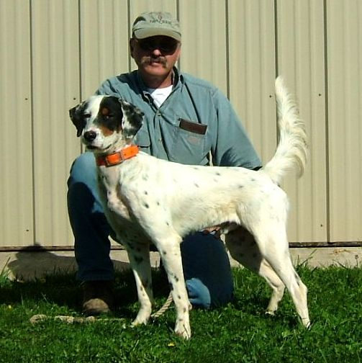
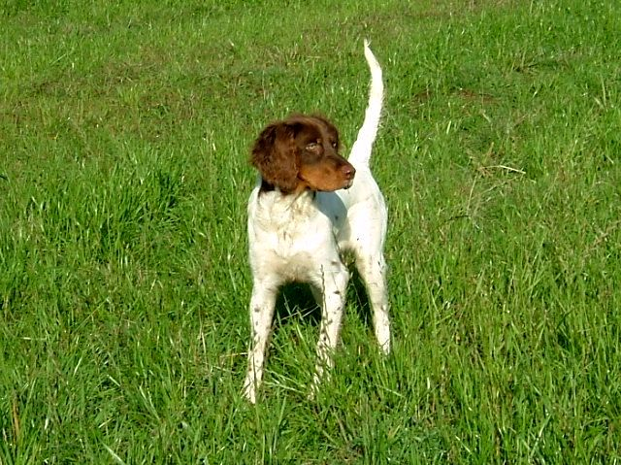

CHOOSING A PUPPY:
Tekoa Mountain is pleased to provide an educated avenue towards the selection of your new puppy! A 50% deposit received will date and place each client on Tekoa’s list of “Choice” and provide an opportunity to choose a pup from any upcoming litter while climbing to the top of the list as clients go home with their new puppies. Specific puppies reserved from a chosen litter are given priority, and as puppies are whelped, a series of communication begins to help each client gain knowledge about the individuals in that litter. Through telephone conversations, photos, and the wonders of E-mail, everyone is able to communicate effectively toward a collective effort to find that special puppy. Puppies are chosen between the 4th and 6th week so preparations for shipments can be organized. Each client reserves the right to choose a pup or pass on to the next litter. After all efforts have been made to help a client choose a pup, or should something come up to change the client’s thinking, the deposit may be returned “in full” at the client’s request. Tekoa believes in total satisfaction toward finding the right dog for you!

PURCHASING A PUP / DOG:
The price of each pup or dog will vary, depending upon the individual(s) being purchased.
To purchase a Tekoa puppy, it is highly recommended to secure a place on the “List of Choice” with a deposit of 50% down.
Puppy prices begin at $800 each and vary considering the proven pedigrees, age, and experience of the pup/dog.
All puppies have had a minimum of one vaccination ( 5-way Duramune Max5Cvk ) and one worming ( Nemex-2 ) prior to leaving Tekoa at 6 to 8 weeks old.
All puppies/dogs shipped are Veterinary inspected.

HEALTH GUARANTEE: ( Please see Health Guarantee page )

SHIPPING / PICKING UP YOUR PUPPY or DOG
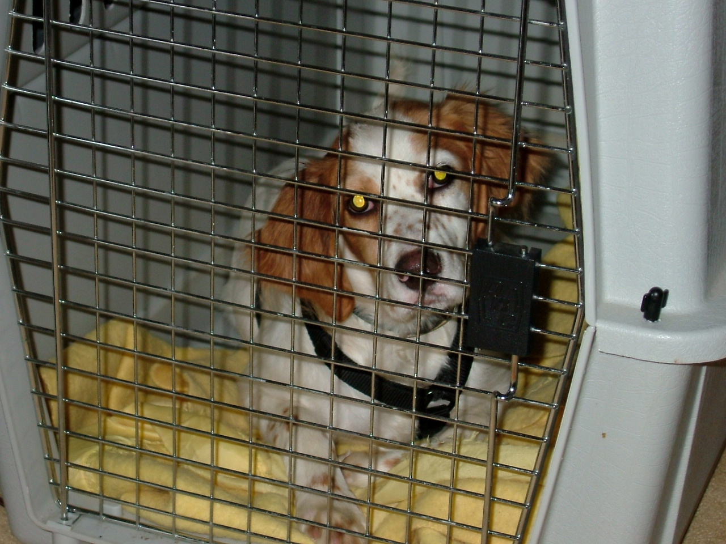
Puppies may be picked up between 6 and 8 weeks old depending on maturity and overall health.
The following applies to all puppies or dogs being shipped:
$45.00 = Health Certificate ONLY – For each pup under 3 mos. and any dog 3 months and older with previous rabies vaccine.
$20.00 = Rabies vaccine ONLY for any pup/dog 3 months and older.
$??.?? = Shipping Crate ( prices vary )
Small crate - “estimated cost” = $55.00
Medium crate - “estimated cost” = $75.00
Large crate - “estimated cost” = $95.00
Note: Prices subject to change.
Please contact ericmauck@aol.com with any questions about our Buying / Shipping information.
Thank you!

